Header Revision

Instructions for revising an existing quote:

Log into the eRapid Quotes system.

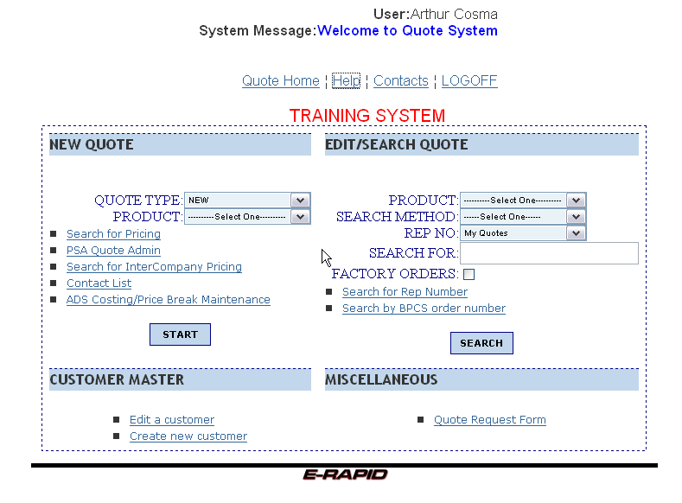

Click on the drop down arrow in the “Product” box, under the “Edit/Search Quote” heading.

Select the desired product ID from the drop down list:

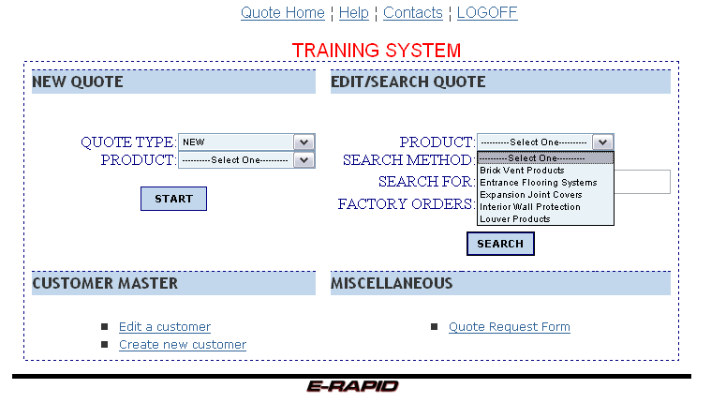
Click on the gray drop down arrow selector at the “Search Method” field and select one of the different ways of searching for an existing quote or order.

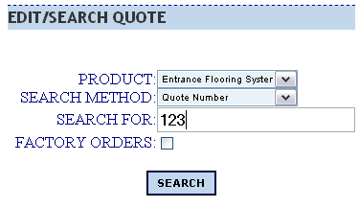

Type in the search criteria (at least 3 characters) and click on the “Search” button. The same basic search rules apply, entering the complete or partial name to search. You may use the ‘%’ as a wildcard, but it’s not required.

If the search criteria matches existing jobs, a list is shown:

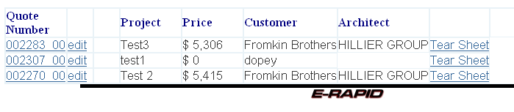

Click on the quote number in the ‘Quote Number’ column to go to the quote header screen.
OR

Click on the ‘edit’ link to skip the header page and go directly to the line item page.
Line item page:

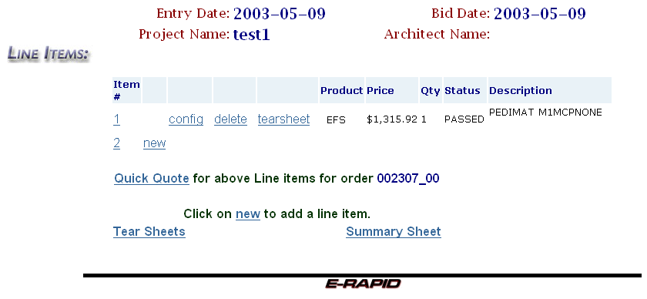

Choices on this page:

- Click on any one of the numbers in the “Item #” column to go into the header screen.
- Click on ‘config’ to go to the configuration of an existing line.
- Click on ‘delete’ to delete the configuration of an existing line.
- Click on ‘new’ to add a new configuration.
- Click on ‘Quick Quote’ to go to the quote calculation and printing screens.
- Click on ‘tearsheet’ to view the tear sheet of an exiting line.
- Click on ‘Tear Sheets’ to view all tear sheets generated for this quote.
- Click on ‘Summary Sheet’ to view the summary for this quote.

Navigation links at the top of the page:

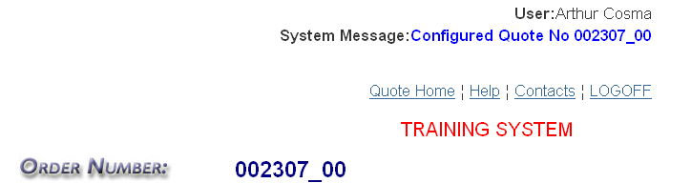

‘Quote Home’ - main (home) page of the eRapid Quotes system.
‘Help’ - help section containg links to documentation and help files.
‘Contacts’ - list of contacts in case you need technical support.
‘LOGOFF’ - if you need to sign out and go back to the user selection list.

